**Atelier développement mobile**

Préparation de l’environnement de développement

* **Installation d’android studio:**

- Veuillez cliquez sur ce lien qui va vous diriger vers la page pour le téléchargement d’Android Studio.

<https://developer.android.com/studio>

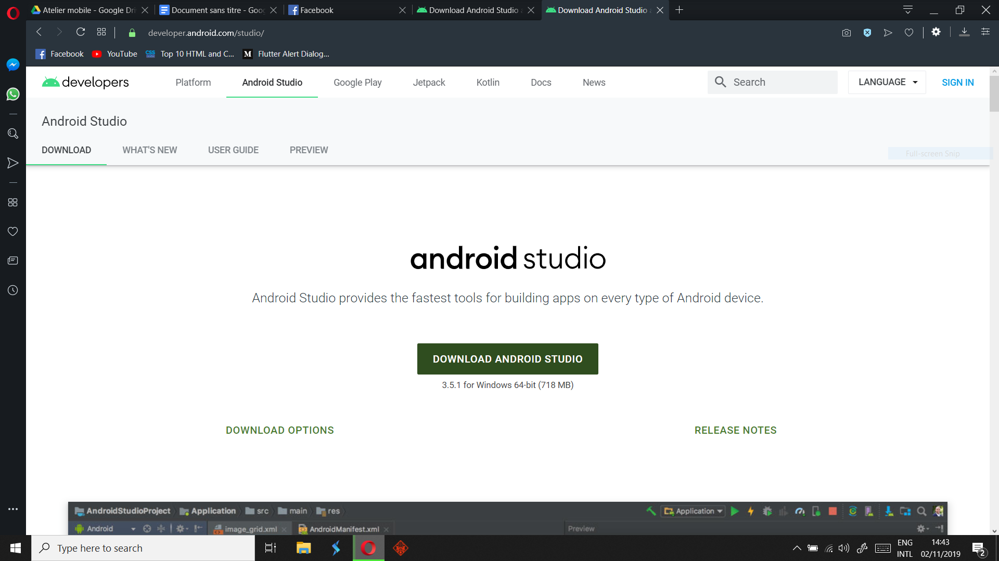

-Cliquez sur “DOWNLOAD ANDROID STUDIO” pour commencer le téléchargement.

La taille du fichier est de 700 mb. Sous wifi, cela va prendre environ 10-15 minutes.

-Attendre la fin du téléchargement et lancer l'exécutable.

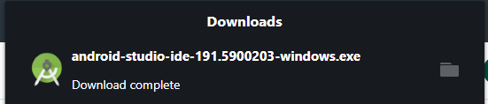

-Durant l’installation vous allez garder la plupart des options en défaut, je mentionnerai les options à modifier.

-Appuyez sur Next.

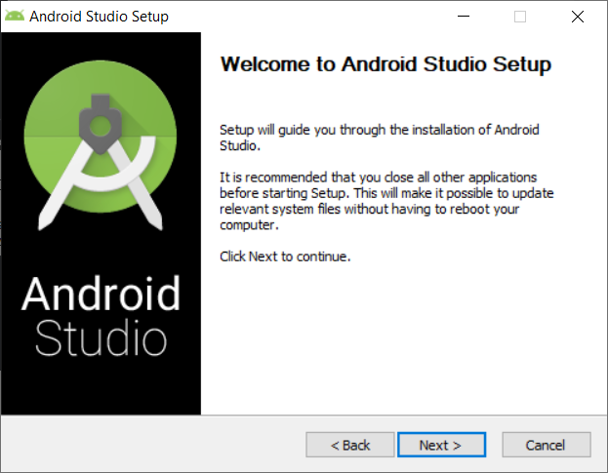

-Si vous avez un bon ordinateur vous pouvez cochez : Android Virtual Device. Cela nous permettra de manipuler des émulateurs. ( Une simulation d’un téléphone mobile dans votre ordinateur qui va vous permettre de tester vos applications )

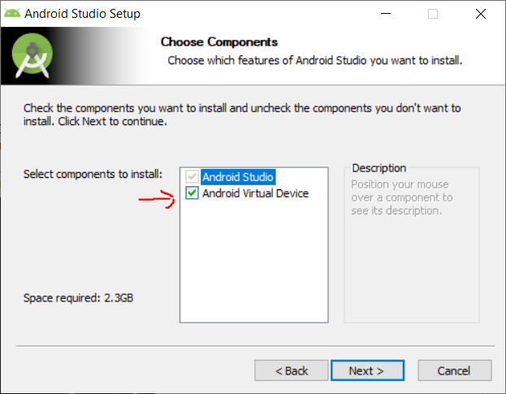

-Le chemin de l’installation, je vous invite à garder le chemin par défaut.

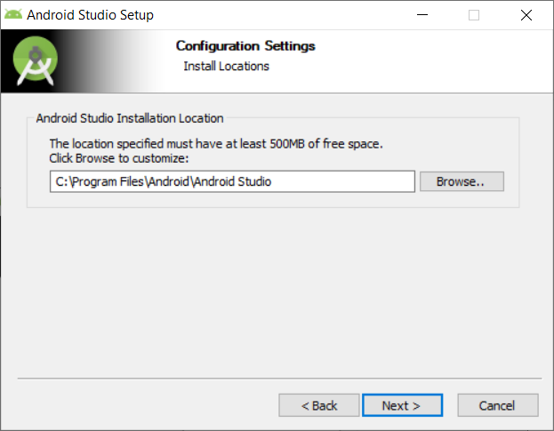

-Cliquez sur Installer.

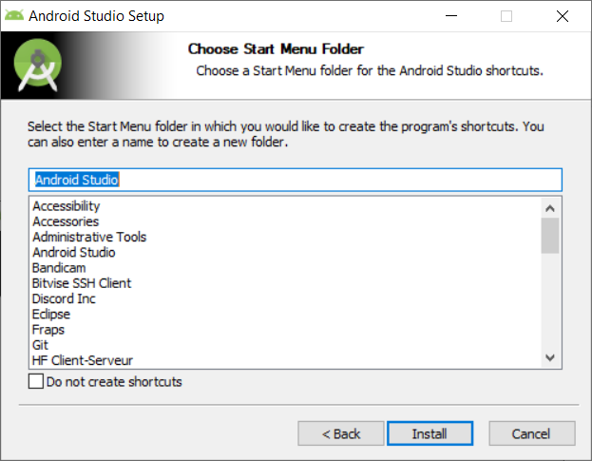

- Attendre la fin de l’installation et puis cliquer sur Next.

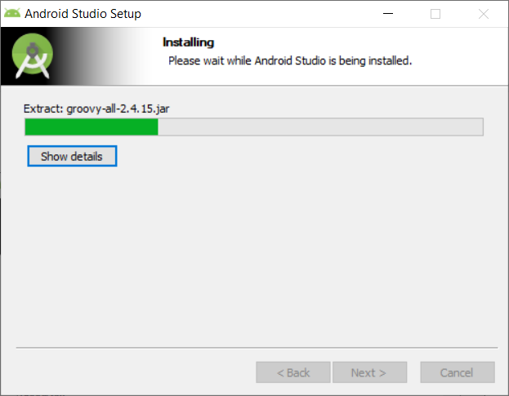

-Moment tant attendu, appuyer sur finish pour lancer Android studio.

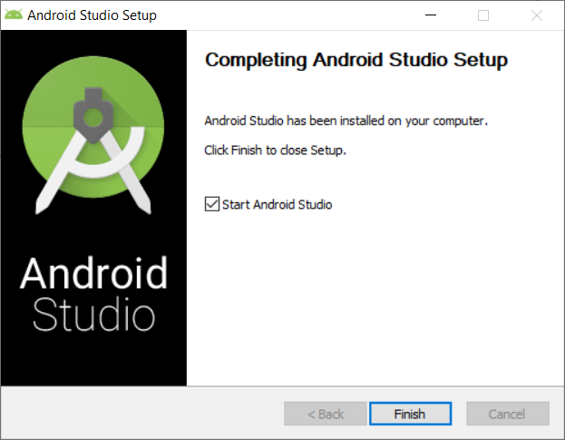

-Dans la première utilisation il vous affichera cette fenêtre..

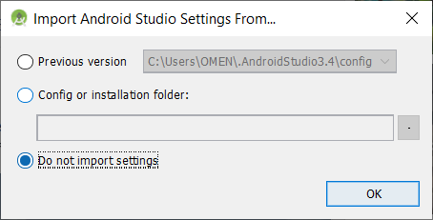

Vous devez toujours resté connecté à internet car des téléchargements peuvent avoir lieu.

* Appuyer sur Next. ( Ne vous inquiétez c’est bientôt finis :p )

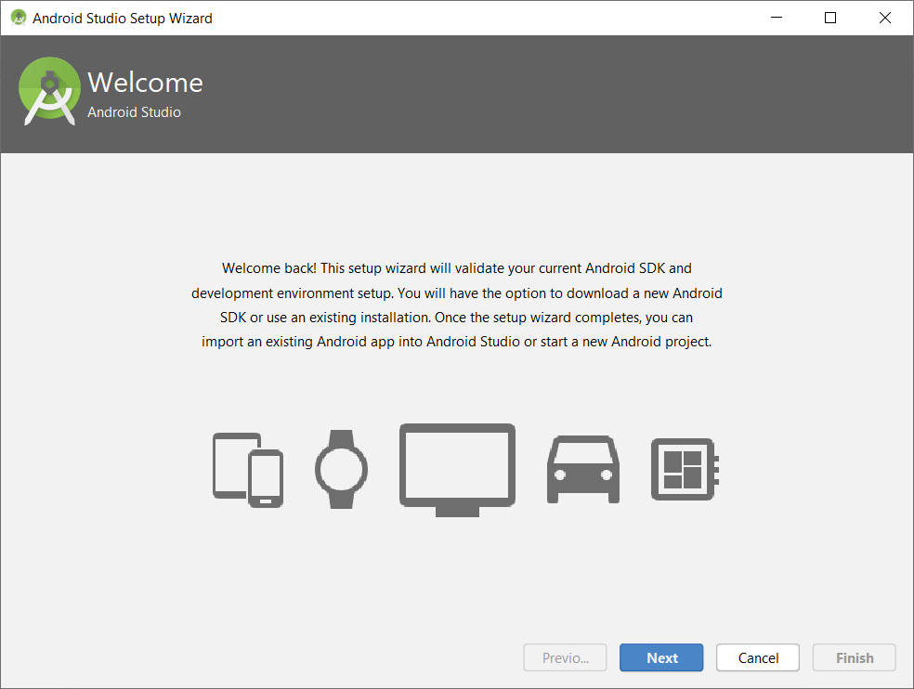

-Choisir “Standard” et continuer.

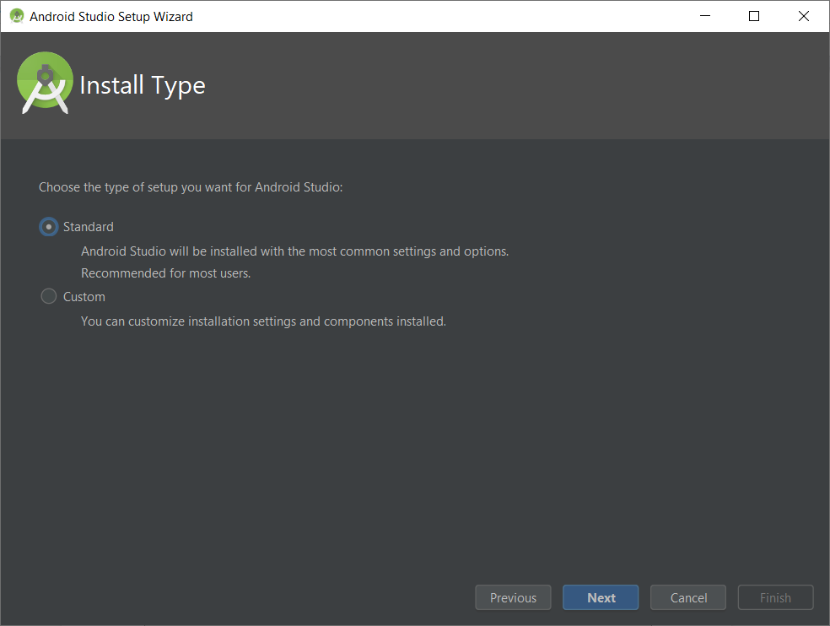

- Choisissez le thème qui vous convient :p ( Je préfère le noir c’est plus adapter à mes yeux)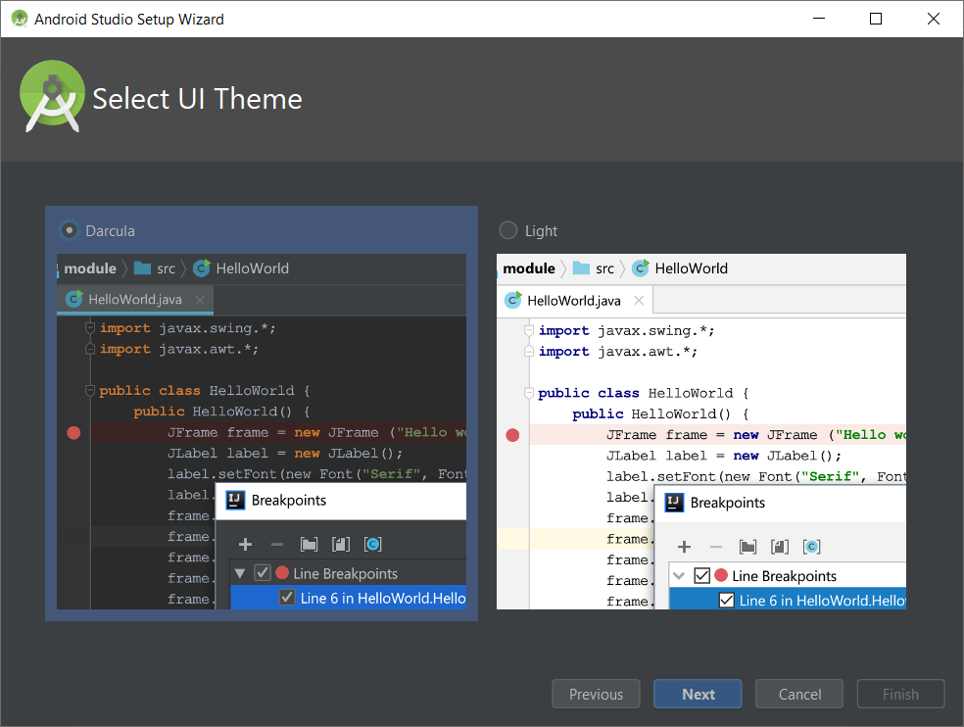

- Assurez vous des cases cochées et appuyer sur next.

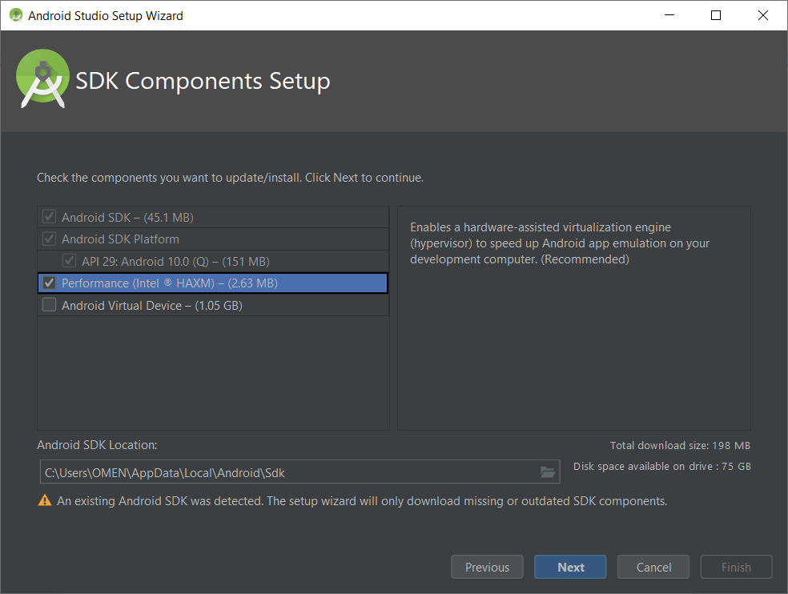

- Appuyez sur finish , allez on y est presque.

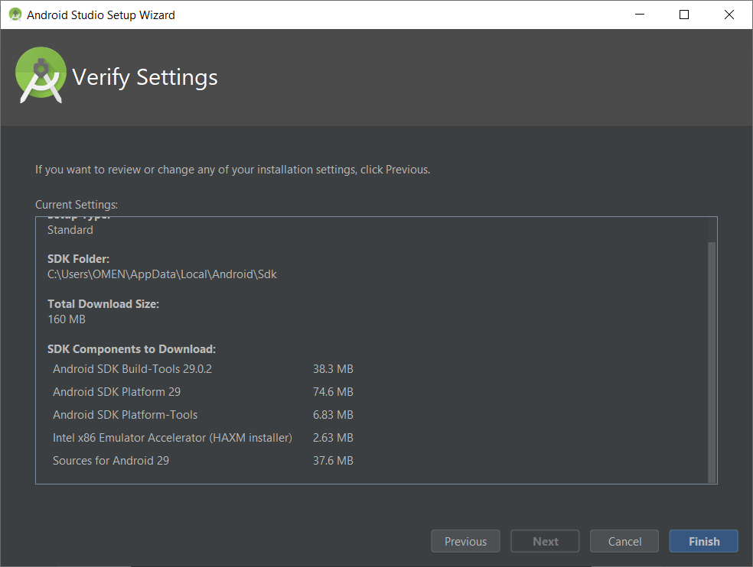

-On attend gentillement la fin du téléchargement, cela ne va pas prendre bcp de temps.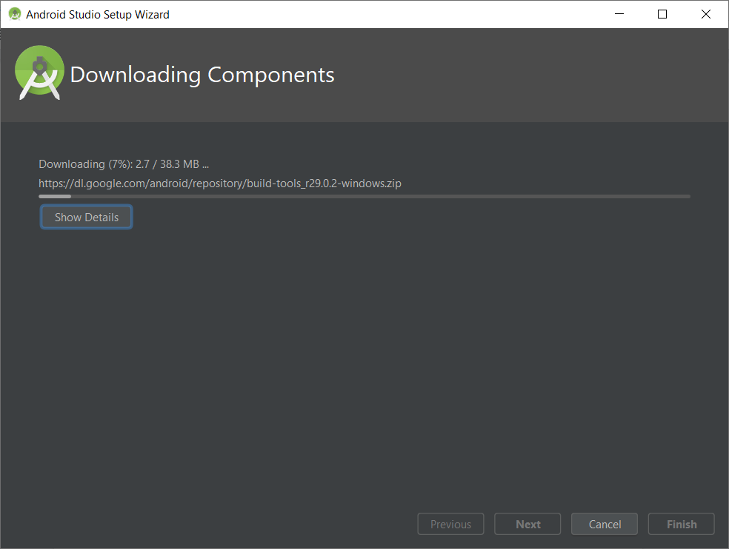

-Et bim, enfin voilà le menu principale d’Android studio. L’installation d’android studio a été effectué avec succès.

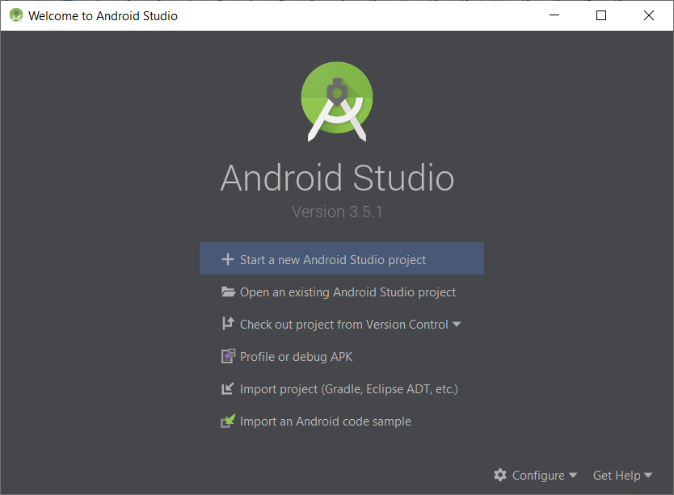

* **Intégration des plugins Flutter et Dart dans Android studio :**

-En bas, veuillez cliquer sur **“Configure”** après cliquer sur “**settings”** dans le petit menu qui va s’afficher.

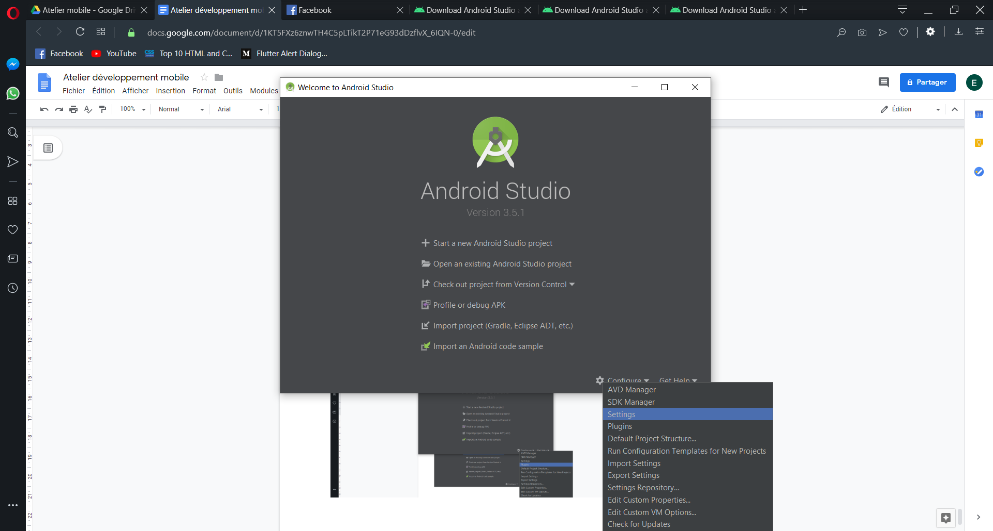

-Dans la liste tout à gauche, cliquer sur l’onglet Plugins puis dans la barre de recherche, écrire Flutter et bien sûr cliquer sur **install**.

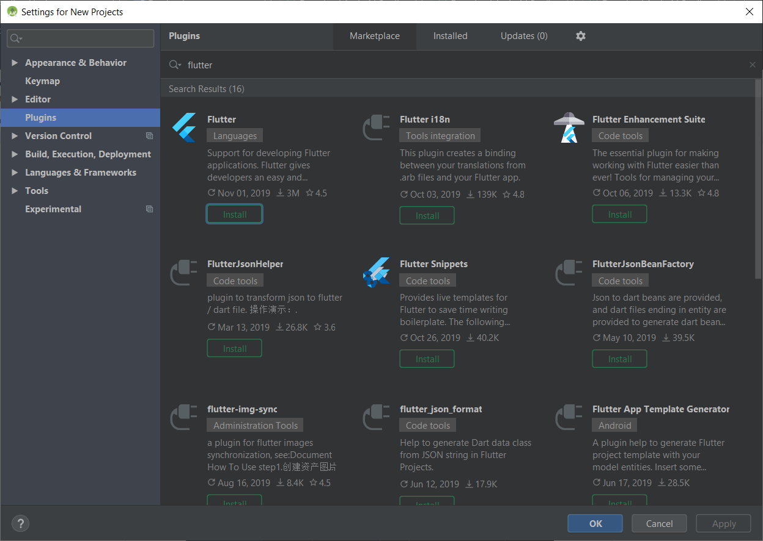

Normalement en installant flutter , le langage dart est installé automatiquement.

Sinon vous devrez faire encore une fois le même manipulation vous rechercher dart et vous l’installer.

il faudra relancer l’IDE pour que les changements prennent effet.

-Quand vous lancerez android studio vous verrez qu’il y a une nouvelle fonction qui est ajouté : **Start a new flutter projec**t. On est dans la bonne route.

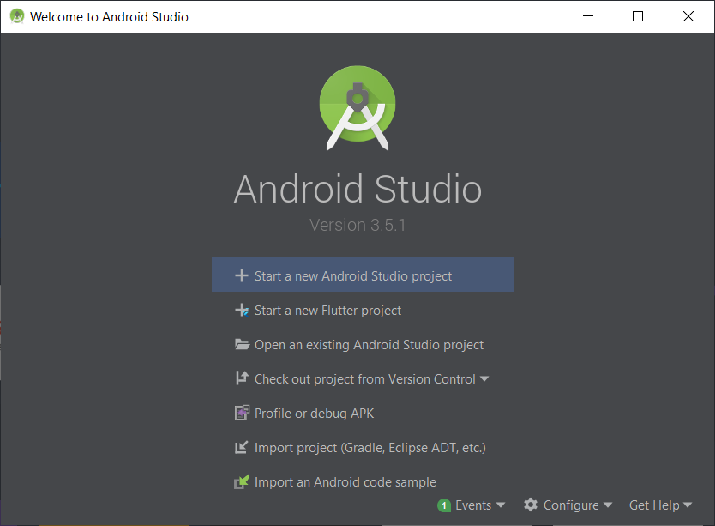

* **Installation du SDK flutter :**

Veuillez cliquer sur ce lien, pour pouvoir télécharger le SDK. Il s’agit d’un fichier rar.

<https://storage.googleapis.com/flutter_infra/releases/stable/windows/flutter_windows_v1.9.1+hotfix.6-stable.zip>

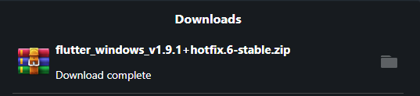

-Je vous invite à créer un dossier src dans le disque C et d’extraire le rar dessus. Après vous lancer le cmd, vous vous déplacer dans C:\src\flutter\bin. Pour faire cela tapez la commande:

cd C:\src\flutter\bin.

Une fois dans ce répertoire veuillez taper la commande suivante : flutter doctor

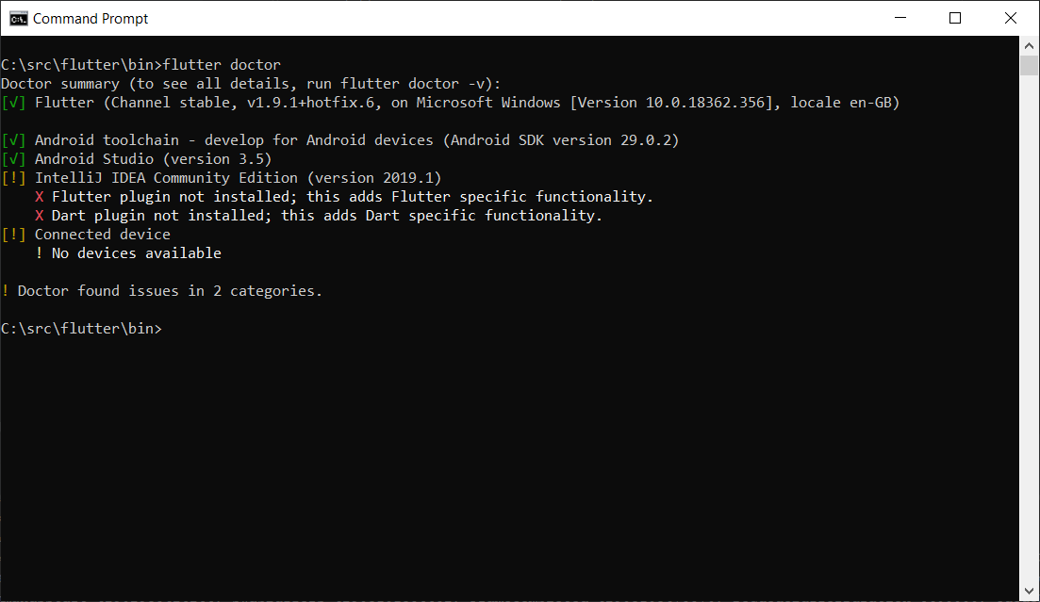

Si il ya une case qui contient croix « X » : il faut tapper la commande :

Flutter flutter doctor --android-licenses

* **Activation du mode de développeur dans le téléphone:**

Pour pouvoir tester nos applications dans nos téléphones, il faudrait activer cette option et aussi le **debug mode**. Puisque cela dépend des téléphones je vous invite à taper le nom de votre téléphone suivi par Activation du mode de développeur dans google. Dans mon cas

j’ai fais la recherche : huwawei P10 activer mode développeur.

Et suivez les instructions. C’est une manipulation de 1 minutes croyez moi. bisou

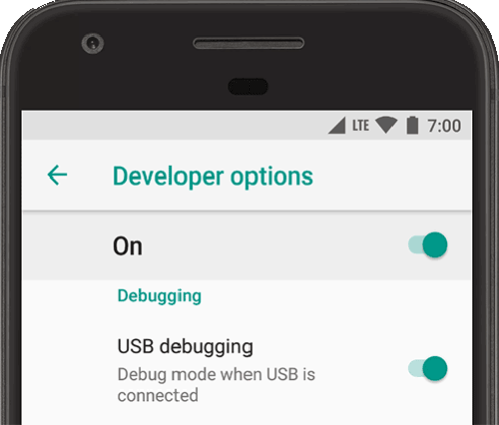

* **Teste de l’environnement :**

-Cliquez sur start a **new flutter project ( non pas start a new android studio project pls )**

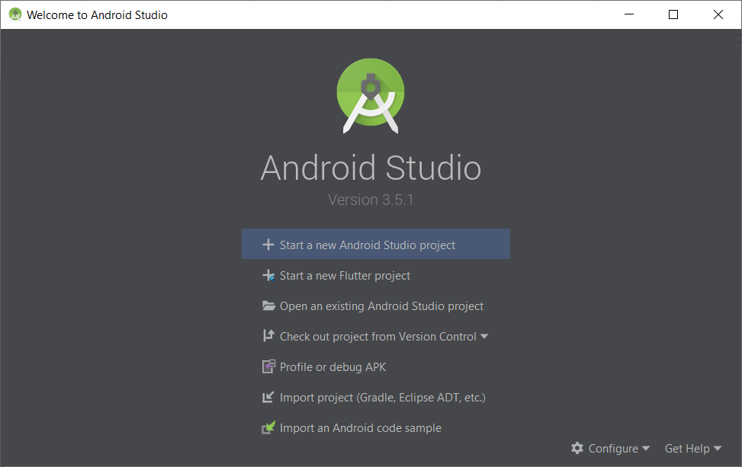

-Choisissez **“Flutter application”**

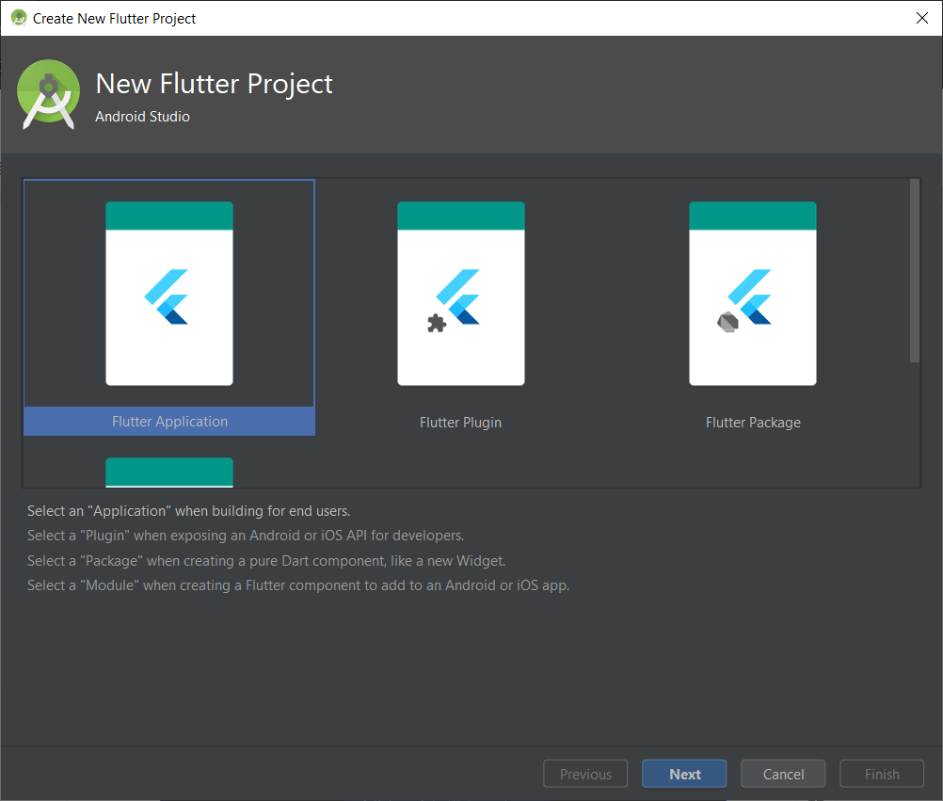

-Remplissez ce formulaire selon vos préférences mais le plus important ici est de préciser le chemin du flutter SDK. Vous vous rappelez ou on a mis flutter SDK? Oui bien vu :-) , on l’a mis dans **C:\src\flutter**

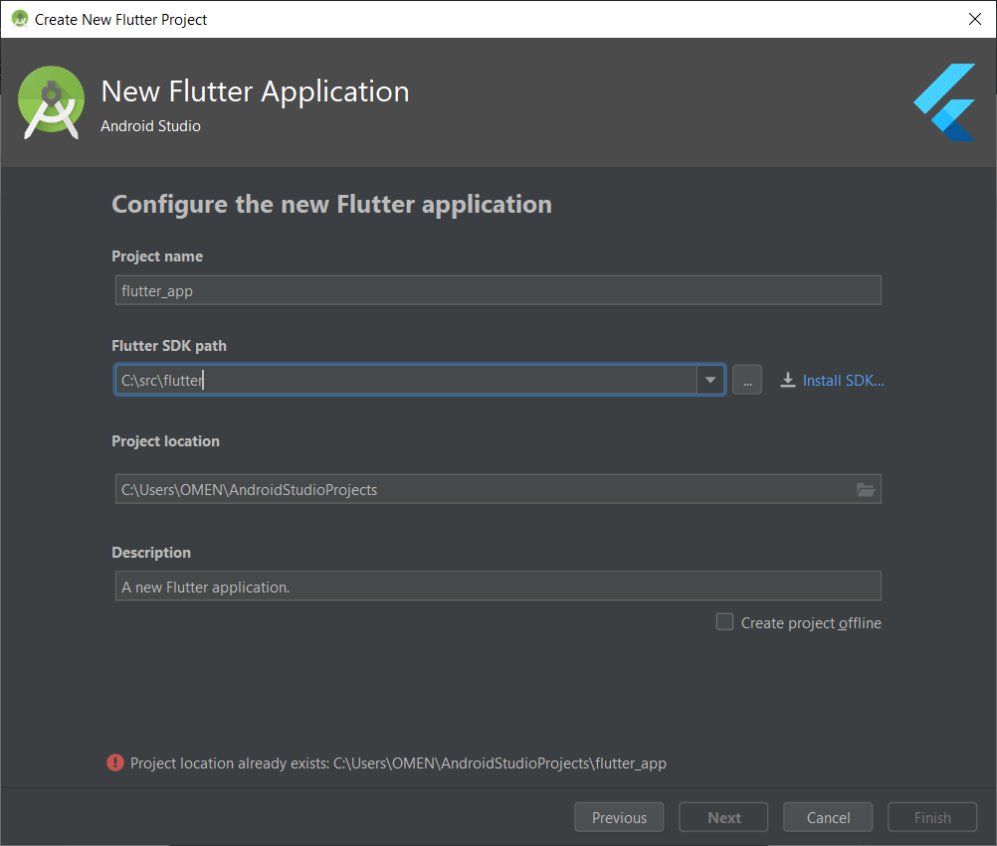

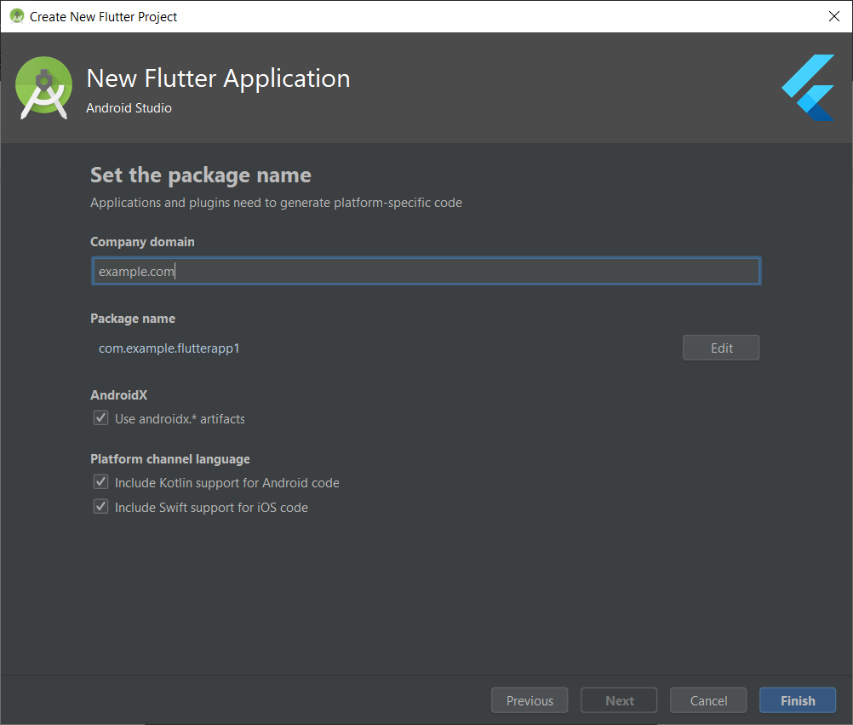

- Android studio va générer une application Flutter basique.

- ça sera le moment de brancher votre téléphone avec votre ordinateur.( type de liaison : **transfert de fichiers** et non pas **chargement uniquement** )

normalement si vous avez bien activé le mode développeur , l’IDE devrait détecter votre téléphone.



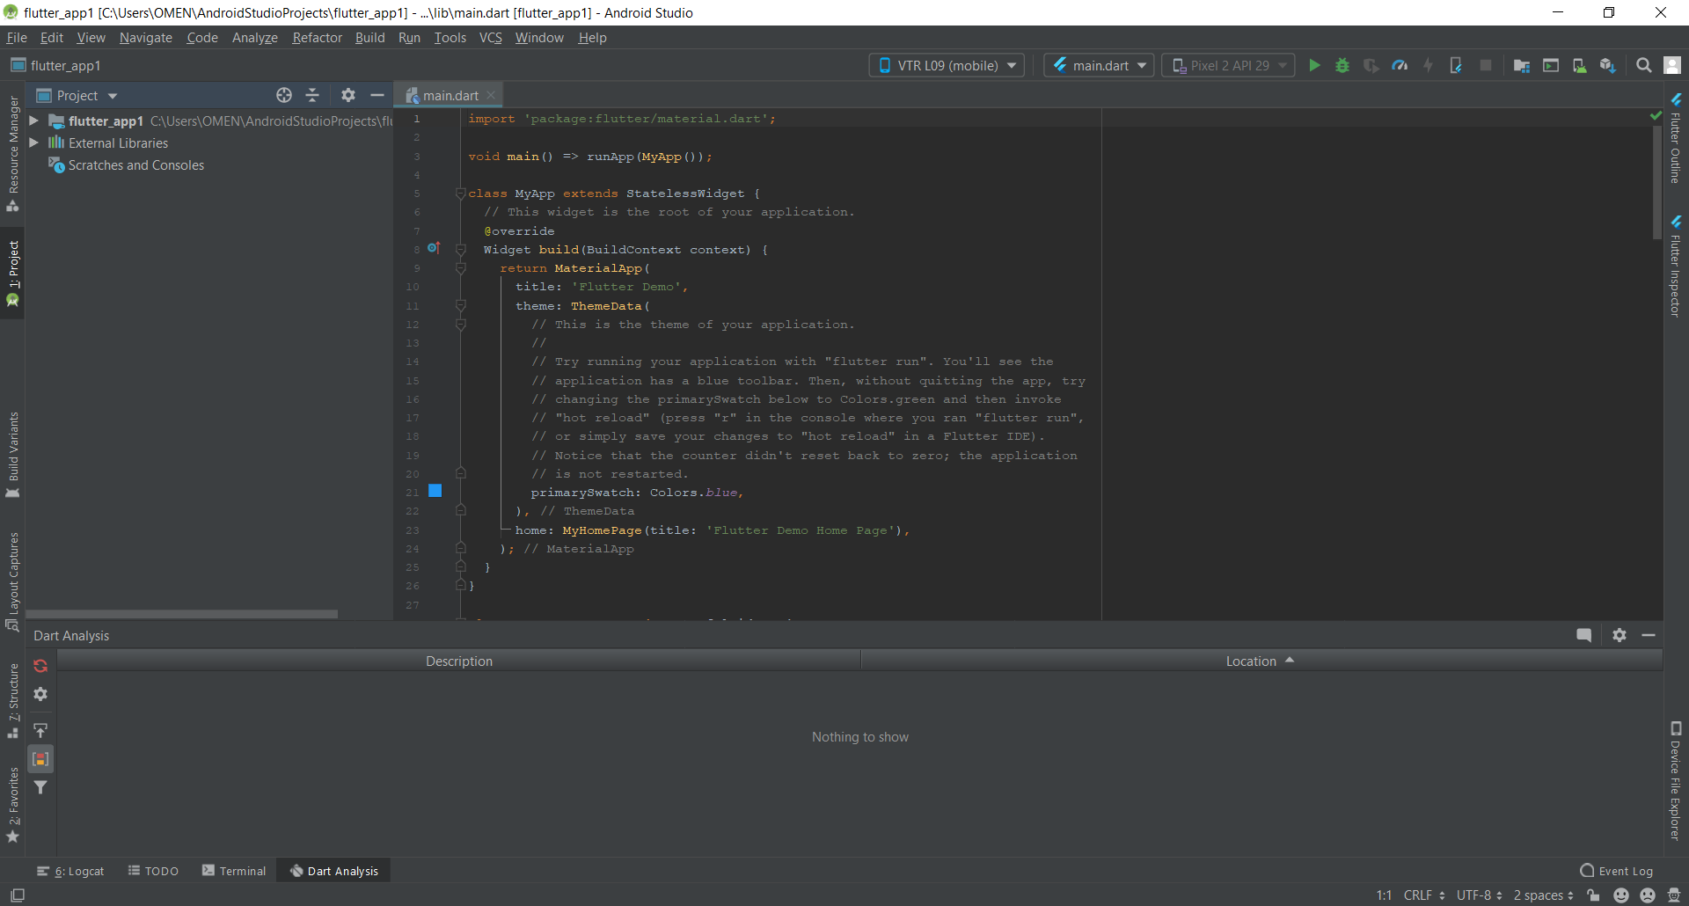

LADIES AND GENTLEMEN THE MOMENT OF TRUTH HAS COME :

-Appuyer sur le bouton **RUN.**



Vous devrez avoir ce résultat dans votre téléphone.

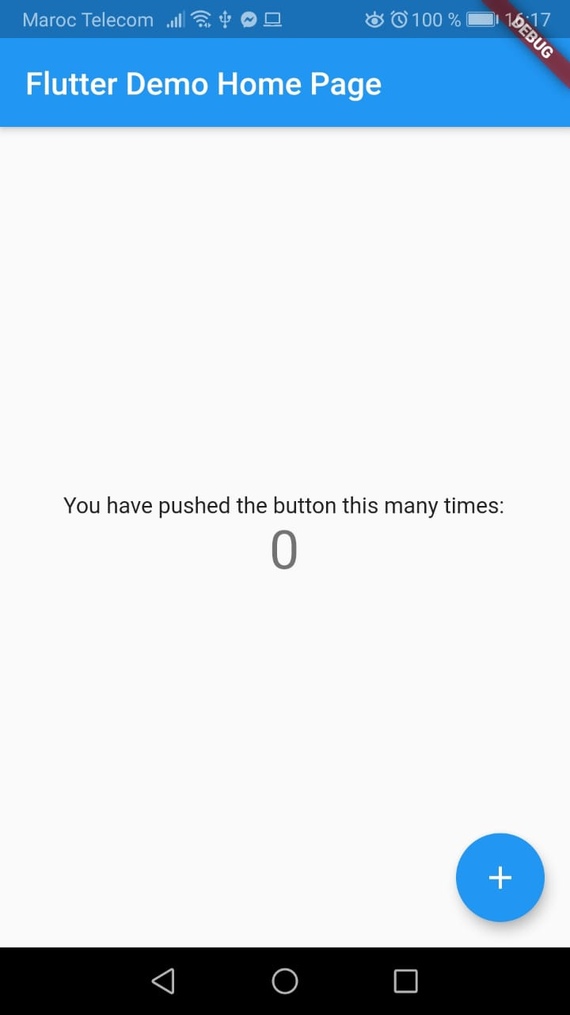

Félicitation d’avoir suivi le tutoriel jusqu’à la fin, si vous avez des problèmes n’hésitez pas à me contacter par mail [elmouradi.amine98@gmail.com](mailto:elmouradi.amine98@gmail.com) ou par whatsapp.

**1er projet : TP week end :**

import 'package:flutter/material.dart';  
  
void main()  
{  
  
 runApp (  
 MaterialApp(  
 home:Scaffold(  
 backgroundColor:Colors.*blue*,  
 body:  
 Column(  
 children: [  
  
 //Image( image: AssetImage("images/image.png"),  
 // //),  
 CircleAvatar( radius :100,  
  
 backgroundImage: AssetImage("images/reda.JPG"),  
  
 ),  
 //CircleAvatar( radius :100,  
  
  
 Text("REDA EL OUAHABI ",style: TextStyle(fontSize: 39,),),  
 Text("mobilie devlopper",style: TextStyle(fontSize: 20,),),  
 Card( child :  
 ListTile(  
 leading: Icon(Icons.*phone*),  
 title:Text("+212618409886")) ,),  
 Card( child :  
 ListTile(  
 leading: Icon(Icons.*email*),  
 title:Text("readaelouahabi@gmail.com")) ,  
 ),  
  
  
 ]  
 ),  
  
 ),  
  
  
  
 ),  
  
  
 );  
}

et n’oublie pas d ajouter la toof ds un dossier cree nome : images et ajouter la chemain relative dans un fichier qui s’appelle : pubspec.yaml et exactement dans assets a la ligne 44 :

assets:  
 - images/reda.JPG

**projet 2 : Plusiers pages** :

ce que j’arrive a faire dans la seance :

import 'package:flutter/cupertino.dart';  
import 'package:flutter/material.dart';  
  
void main(){  
 runApp(MyApp());  
}  
  
  
  
  
  
  
class MyApp extends StatelessWidget {  
 @override  
 // This widget is the root of your application.  
  
 Widget build(BuildContext context) {  
 return MaterialApp(  
 home: MyHomePage(),  
 );  
 }  
  
}  
  
class MyHomePage extends StatelessWidget{  
 @override  
 Widget build(BuildContext context){  
 return Scaffold(  
 appBar:AppBar(  
 title: Text("my test"),  
 ),  
 body: Center(  
 child: Column(  
 mainAxisAlignment: MainAxisAlignment.center,  
 children: <Widget>[  
 Text(  
 "home page",style: TextStyle(fontSize: 30,),  
 ),  
 SizedBox(  
 height: 40,  
 ),  
  
 ],  
 ),  
 )  
  
 );  
 }  
  
 }  
class MySecondPage extends StatelessWidget {  
 @override  
 Widget build(BuildContext context) {  
 return Scaffold(  
 appBar: AppBar(  
 title: Text("my test 2"),  
 ),  
 body: Center(  
 child: Text("second page",style: TextStyle(fontSize: 80,color: Colors.*blue*,)),  
 )  
  
 );  
 }  
}

**projet 3 : Iam Rich**

import"package:flutter/material.dart";  
void main()  
{  
 runApp(  
 MaterialApp(  
 home: Scaffold(  
 backgroundColor: Colors.*lightBlueAccent*,  
 body:  
 ListView(  
 children: [  
 Image( image: AssetImage("images/image.jpeg"),  
 width: 300,  
 height: 500,  
 ),  
  
 Text("electronique de base ",style: TextStyle(fontSize: 20,),),  
 ],  
  
 ),  
 appBar : AppBar( title:Text("hello world")  
 ),  
 ),  
 ),  
 );  
}

avec l ajout de dossier images + limage a afficher + la modification de assets :

assets:  
 - images/image.jpeg

stless : créer un class

MaterialApp

Pour le design

Statful : page dynamique/t

debugShowCheckedModeBanner: false,

enlever debug

il existe : soit rows soit column .

4eme APP :

import 'package:flutter/material.dart';  
  
main() {  
 runApp(Myapp());  
}  
  
class Myapp extends StatelessWidget {  
 @override  
 Widget build(BuildContext context) {  
 return MaterialApp(  
 title: "basic app",  
 debugShowCheckedModeBanner: false,  
 home: MyHomepage(),  
 );  
 }  
}  
  
class MyHomepage extends StatefulWidget {  
 @override  
 _MyHomepageState createState() => _MyHomepageState();  
}  
  
class _MyHomepageState extends State<MyHomepage> {  
 int counter = 0;  
 @override  
 Widget build(BuildContext context) {  
 return Scaffold(  
 appBar: AppBar(  
 title: Text("Mooli My Life -🌹, My love 💖 & my ALL ❤" , style: TextStyle( fontSize: 50),),  
  
 ),  
 body: Column(  
 children: <Widget>[  
 Text(  
 counter.toString(),  
 style: TextStyle(fontSize: 30, fontWeight: FontWeight.*bold*),  
 ),  
 FlatButton(  
 child: Icon(Icons.*add*),  
 onPressed: () {  
 setState(() {  
 counter++;  
 });  
 },  
 ),  
 FlatButton(  
 child: Icon(Icons.*remove*),  
 onPressed: () {  
 setState(() {  
 counter--;  
 });  
 },  
 ),  
 ],  
 ),  
 floatingActionButton: FloatingActionButton(  
 onPressed: () {  
 setState(() {  
 counter++;  
 });  
 },  
 ),  
 );  
 }  
}

cadeau moli 18/01/2020

import 'package:flutter/material.dart';  
  
main() {  
 runApp(Myapp());  
}  
  
class Myapp extends StatelessWidget {  
 @override  
 Widget build(BuildContext context) {  
 return MaterialApp(  
 title: "basic app",  
 debugShowCheckedModeBanner: false,  
 home: MyHomepage(),  
 );  
 }  
}  
  
class MyHomepage extends StatefulWidget {  
 @override  
 _MyHomepageState createState() => _MyHomepageState();  
}  
  
class _MyHomepageState extends State<MyHomepage> {  
 int counter = 1;  
 @override  
 Widget build(BuildContext context) {  
 return Scaffold(  
 appBar: AppBar(  
 title: Text("Mooli My Life -🌹, My love 💖 & my ALL ❤" , style: TextStyle( fontSize: 15),),  
  
 ),  
 body: Column(  
 children: <Widget>[  
 Text(" لمياء , أحبك كثيرا و سأبقى معك ما حييت "  
 ",, لن اقترب من غيرك ولن اعطي قلبي لغيرك .. كل الاهتمام والحنان لك "  
 ", كل الحب لا تبتعدي عني 💕 الان انا أحبك في الله "  
 ""+ counter.toString()+  
 " مرة اكثر من قبل ان تضغطي على الزر"  
 " وسأنتظر لحظة جمعنا بنفس الشوق 🌹 انا لك وانت لي❤ "  
 " ❤ لك كل ذرة من قلبي ❤",  
 style: TextStyle(fontSize: 30 , fontWeight: FontWeight.*bold*),),  
 FlatButton(  
 child: Icon(Icons.*add*),  
 onPressed: () {  
 setState(() {  
 counter*=100;  
  
  
 });  
 },  
 ),  
  
 ],  
 ),  
  
 );  
 }  
}

last version :

import 'package:flutter/material.dart';  
  
main() {  
 runApp(Myapp());  
}  
  
class Myapp extends StatelessWidget {  
 @override  
 Widget build(BuildContext context) {  
 return MaterialApp(  
 title: "basic app",  
 debugShowCheckedModeBanner: false,  
 home: MyHomepage(),  
 );  
 }  
}  
  
class MyHomepage extends StatefulWidget {  
 @override  
 _MyHomepageState createState() => _MyHomepageState();  
}  
  
class _MyHomepageState extends State<MyHomepage> {  
 int counter = 1;  
 @override  
 Widget build(BuildContext context) {  
 return Scaffold(  
 appBar: AppBar(  
 backgroundColor: Colors.pinkAccent,  
 title: Text(  
 "Mooli My Life -🌹, My love 💖 & my ALL ❤",  
 style: TextStyle(fontSize: 15),  
 ),  
 ),  
 body: ListView(  
 children: [  
 Center(  
 child: Text(  
 " لمياء , أحبك كثيرا و سأبقى معك ما حييت "  
 ",, لن اقترب من غيرك ولن اعطي قلبي لغيرك .. كل الاهتمام والحنان لك "  
 ", كل الحب لا تبتعدي عني 💕 الان انا أحبك في الله : "  
 " " +  
 counter.toString() +  
 " مرة اكثر من قبل ان تضغطي على الزر "  
 " وسأنتظر لحظة جمعنا بنفس الشوق 🌹 انا لك وانت لي❤ "  
 " ❤ لك كل ذرة من قلبي ❤",  
 style: TextStyle(fontSize: 30, fontWeight: FontWeight.bold),  
 ),  
 ),  
 /*FlatButton(  
 child: Icon(Icons.add),  
 onPressed: () {  
 setState(() {  
 counter*=100;  
  
  
 });  
 },  
 ),  
 CircleAvatar( radius :50,  
  
 backgroundImage: AssetImage("images/image2my.jpg"),  
  
 ),  
 CircleAvatar( radius :50,  
  
 backgroundImage: AssetImage("images/moli.jpeg.png"),  
  
 ),*/  
 Image( image: AssetImage("images/image1.png"),  
 width: 300,  
 height: 500,  
 ),  
  
  
  
  
 ],  
  
  
 ),  
 floatingActionButton: FloatingActionButton(  
 onPressed: () {  
 setState(() {  
 counter += 100;  
 });  
 },  
 backgroundColor: Colors.purple,  
 ),  
 );  
 }  
}

last version 22/01/2020 02 :01

import 'package:flutter/material.dart';  
  
main() {  
 runApp(Myapp());  
}  
  
class Myapp extends StatelessWidget {  
 @override  
 Widget build(BuildContext context) {  
 return MaterialApp(  
 title: "basic app",  
 debugShowCheckedModeBanner: false,  
 home: MyHomepage(),  
 );  
 }  
}  
  
class MyHomepage extends StatefulWidget {  
 @override  
 _MyHomepageState createState() => _MyHomepageState();  
}  
  
class _MyHomepageState extends State<MyHomepage> {  
 int counter = 1;  
 @override  
 Widget build(BuildContext context) {  
 return Scaffold(  
 appBar: AppBar(  
 backgroundColor: Colors.*pinkAccent*,  
 title: Text(  
 "Mooli My Life -🌹, My love 💖 & my ALL ❤",  
 style: TextStyle(fontSize: 15),  
 ),  
 ),  
 body: ListView(  
 children: [  
 Center(  
 child: Text(  
 " لمياء , أحبك كثيرا و سأبقى معك ما حييت "  
 ",, لن اقترب من غيرك ولن اعطي قلبي لغيرك .. كل الاهتمام والحنان لك "  
 "و كل الحب , لا تبتعدي عني 💕 الان انا أحبك في الله : "  
 " " +  
 counter.toString() +  
 " مرة اكثر من قبل ان تضغطي على الزر "  
 " وسأنتظر لحظة جمعنا بنفس الشوق 🌹 انا لك وانت لي❤ "  
 " ❤ لك كل ذرة من قلبي ❤",  
 style: TextStyle(fontSize: 30, fontWeight: FontWeight.*bold*),  
 ),  
 ),  
 Row(  
 children: [  
 FlatButton(  
 child:  
  
 Icon(Icons.*favorite* , size: 40,),  
  
 onPressed: () {  
 setState(() {  
 counter+=99;  
  
  
 } );  
  
 },  
  
 ),  
 Text("👈👈 💙💚💜💛🤎🧡 👉👉"),  
 FlatButton(  
 child:  
  
 Icon(Icons.*favorite_border* , size: 40,),  
  
 onPressed: () {  
 setState(() {  
 counter+=99;  
  
  
  
 } );  
  
 },  
  
 ),  
 ],  
 ),  
 /*FlatButton(  
 child: Icon(Icons.add),  
 onPressed: () {  
 setState(() {  
 counter*=100;  
  
  
 });  
 },  
 ),  
 CircleAvatar( radius :50,  
  
 backgroundImage: AssetImage("images/image2my.jpg"),  
  
 ),  
 CircleAvatar( radius :50,  
  
 backgroundImage: AssetImage("images/moli.jpeg.png"),  
  
 ),*/  
 Image( image: AssetImage("images/image1.png"),  
 width: 300,  
 height: 500,  
 ),  
 Row(  
 children: [  
 FlatButton(  
 child:  
  
 Icon(Icons.*favorite* , size: 30,),  
  
 onPressed: () {  
 setState(() {  
 counter+=99;  
  
  
 } );  
  
 },  
  
 ),  
 Text("👈👈 💙💚💜💛🤎🧡 👉👉"),  
 FlatButton(  
 child:  
  
 Icon(Icons.*favorite_border* , size: 30,),  
  
 onPressed: () {  
 setState(() {  
 counter+=99;  
  
  
  
 } );  
  
 },  
  
 ),  
 ],  
 ),  
  
Row (  
 children: <Widget>[  
 CircleAvatar( radius :90,  
  
 backgroundImage: AssetImage("images/moli2.png"),  
  
 ),  
 CircleAvatar( radius :90,  
  
 backgroundImage: AssetImage("images/image2my.jpg"),  
  
 ),  
  
 ],  
),  
 Text("🤲💑💍 👈👈🌹🌸🌸🌺🌺🌺🌺🌸🌸🌹 👉👉 💍💑🤲", style: TextStyle(fontSize: 30 ,backgroundColor: Colors.*white*),),  
 Text("I hope that my next days and years with you will be better and more confortable for us "  
 ", I really care about that , "  
 "and i want to finish my small gift by telling you that :"  
 "I wiil love you from that day that I knew you "  
 "until the last of my days ❤ ,,"  
 " and you can imagine how mush My Love is getting more and more than any past time ."  
 , style: TextStyle(fontSize: 30 ,backgroundColor: Colors.*pinkAccent*),),  
 Text("Kanebghiik Bezaaf Wlah 3alem ❤❤", style: TextStyle(fontSize: 30 ,backgroundColor: Colors.*white*),),  
 Text("dont forget that : I AM HERE FOR YOU !🌸❤", style: TextStyle(fontSize: 30 ,backgroundColor: Colors.*red*),),  
 ],  
  
  
 ),  
  
 floatingActionButton: FloatingActionButton(  
 child: Icon(Icons.*favorite*),  
 onPressed: () {  
 setState(() {  
 counter += 99;  
 });  
 },  
 backgroundColor: Colors.*purple*,  
 ),  
  
 );  
 }  
}

**Summer Works !**

import 'package:flutter/material.dart';  
  
void main() {  
 runApp(MyApp());  
}  
  
class MyApp extends StatelessWidget {  
 @override  
 Widget build(BuildContext context) {  
 return MaterialApp(  
 home: Scaffold(  
 backgroundColor: Colors.*teal*[900],  
 body: SafeArea(  
 child: Row(  
 //crossAxisAlignment: CrossAxisAlignment.stretch,  
// mainAxisAlignment: MainAxisAlignment.spaceBetween,  
 children: <Widget>[  
 Container(  
 width: 100.0,  
 color: Colors.*red*,  
 ),  
 Container(  
 width: 200,  
 child: Column(  
 mainAxisAlignment: MainAxisAlignment.center,  
 children: <Widget>[  
 Container(  
 color: Colors.*yellow*,  
 width: 60.0,  
 height: 50.0,  
 ),  
 Container(  
 color: Colors.*green*,  
 width: 60.0,  
 height: 50.0,  
 ),  
 ],  
 ),  
 ),  
 Container(  
 width: 100,  
 color: Colors.*blue*,  
 ),  
 ],  
 ),  
 )  
 ),  
 );  
 }  
}

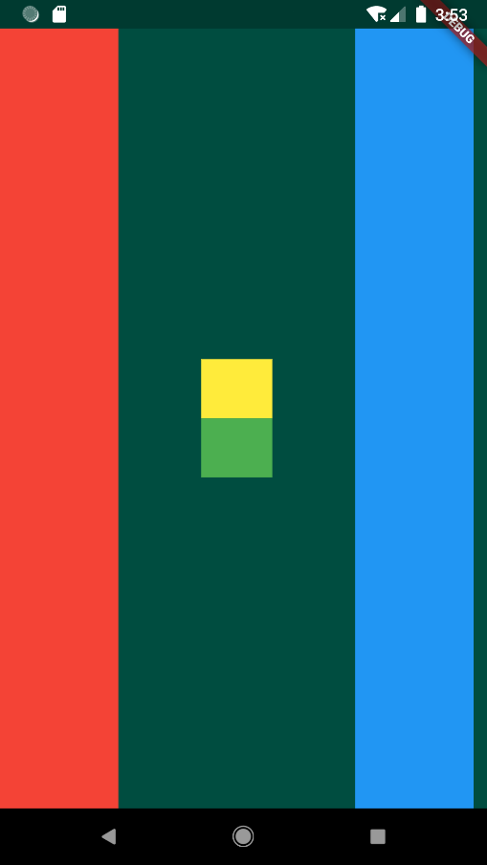

Mi Card App

import 'package:flutter/material.dart';  
  
void main() {  
 runApp(MyApp());  
}  
  
class MyApp extends StatelessWidget {  
 @override  
 Widget build(BuildContext context) {  
 return MaterialApp(  
 home: Scaffold(  
 backgroundColor: Colors.*teal*[900],  
 body: SafeArea(  
 child: Column(  
 // mainAxisAlignment: MainAxisAlignment.center,  
 children: <Widget>[  
 CircleAvatar(  
 *///widgets pour dessiner une cercle sur l'image .* radius: 100,  
 backgroundImage: AssetImage(  
 //on fait l'ajouter dans le fichier YAML  
 "images/image.jpg",  
 ),  
 ),  
 SizedBox(  
 height: 10,  
 ),  
 Text(  
 'Reda EL OUAHABI',  
 style: TextStyle(  
 color: Colors.*blue*,  
 letterSpacing: 2.5,  
 fontSize: 36.0,  
 fontStyle: FontStyle.italic,  
 fontWeight: FontWeight.*w900*,  
 fontFamily: 'Pacifico',  
 ),  
 ),  
 Text(  
 'Software Developer',  
 style: TextStyle(  
 color: Colors.*blue*[500],  
 letterSpacing: 2.5,  
 fontSize: 30.0,  
 fontStyle: FontStyle.italic,  
 //fontWeight: FontWeight.bold,  
 fontFamily: 'Modak',  
 ),  
 ),  
 SizedBox(  
 height: 10,  
 width: 250,  
 child: Divider(  
 color: Colors.*amber*,  
 ),  
 ),  
 SizedBox(  
 height: 20,  
 width: 250,  
 child: Divider(  
 color: Colors.*amber*,  
 ),  
 ),  
 Card(  
 child: ListTile(  
 leading: Icon(Icons.*map*),  
 title: Text('Tayda ❤',  
 style: TextStyle(  
 color: Colors.*red*[500],  
 fontSize: 30.0,  
 fontStyle: FontStyle.italic,  
 fontWeight: FontWeight.*bold*,  
 fontFamily: 'Pacifico',  
 ),  
 ),  
 ),  
 ),  
 Card(  
 child: ListTile(  
 leading: Icon(Icons.*phone*),  
 title: Text(  
 "+212618409886",  
 ),  
 ),  
 ),  
  
 Card(  
 child: ListTile(  
 leading: Icon(Icons.*mail*),  
 title: Text('redaelouahabi98@gmail.com'),  
 ),  
 ),  
 ],  
 ),  
 )),  
 debugShowCheckedModeBanner: false,  
 );  
 }  
}

With Icon [voir la note pour agir sur l’Icon]

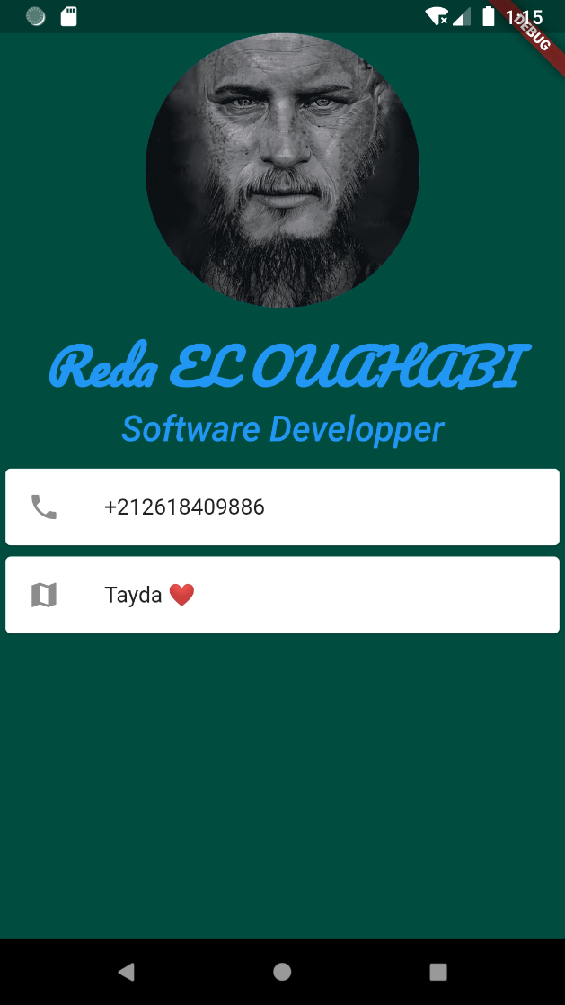

* **Frère & Sœur App :[too rich at the level at container/rows columns ,,]**
* *///je veux organiser plusieurs elts sur le meme ligne/row , comment?!!  
  ///pour les colonnes , on utilise listView*import "package:flutter/material.dart";  
    
  void main() {  
   runApp(MyApp());  
  }  
    
  class MyApp extends StatelessWidget {  
   @override  
   Widget build(BuildContext context) {  
   return MaterialApp(  
   home: Scaffold(  
   //scaffold for the beautiful view  
   backgroundColor: Colors.*green*[300],  
   body: ListView(  
   //pour permettre ascender dans la page [ != collumn & rows ,, they don't allow its ]  
   children: [  
   Row(  
   children:[  
   Image(  
   image: AssetImage("images/image.jpeg"),  
   width: 300,  
   height: 300,  
   ),  
   ]  
   ),  
   Column(  
   *///cette liste view est composer d'un coulumn avec plusieurs widgets .*// mainAxisSize: MainAxisSize.min,/// la colonne ne prend en compte que le minimum des widgets , et pas tout la colonne !  
  // verticalDirection: VerticalDirection.down,///changer la direction des colonnes [up /down{default}]  
  // mainAxisAlignment: MainAxisAlignment.center, ///the point of start of our container [vertical version !] /y  
  // ///there is also spacebetween fct  
  // crossAxisAlignment: CrossAxisAlignment.center, ///the point of start of our container [horizontal version !] /x  
  // ///there is also stretch fct to do a dilation for all your widgets at the column  
   children: <Widget>[  
   Container(  
   //width: double.infinity,  
   height: 50,  
   ),  
   //For free Space [50Px Exactly] , you just need to add this widget whenever you like !  
   SizedBox(  
   height: 50,  
   ),  
   CircleAvatar(  
   *///widgets pour dessiner une cercle sur l'image .* radius: 100,  
   backgroundImage: AssetImage(  
   //on fait l'ajouter dans le fichier YAML  
   "images/imagee.jpg",  
   ),  
   ),  
   Text(  
   "je t'aime mon frere ♥❤♥ ",  
   style: TextStyle(  
   fontSize: 30,  
   fontWeight: FontWeight.*bold*,  
   backgroundColor: Colors.*amberAccent*,  
   ),  
   ),  
   Image(  
   image: AssetImage("images/image.jpeg"),  
   width: 300,  
   height: 300,  
   ),  
   Text(  
   "je t'aime ma soeur ♥❤♥ ",  
   style: TextStyle(  
   fontSize: 30,  
   fontWeight: FontWeight.*bold*,  
   ),  
   ),  
   Card(  
   *///dessiner une card avec l'icone de telephone* child: ListTile(  
   leading: Icon(  
   Icons.*phone*,  
   ),  
   title: Text(  
   "+212618409886",  
   ),  
   ),  
   ),  
   ],  
   ),  
   ],  
   ),  
   appBar: AppBar(  
   title: Text(  
   "hello World",  
   ),  
   backgroundColor: Colors.*purple*[300],  
   ),  
   ),  
   debugShowCheckedModeBanner: false,  
   );  
   }  
  }

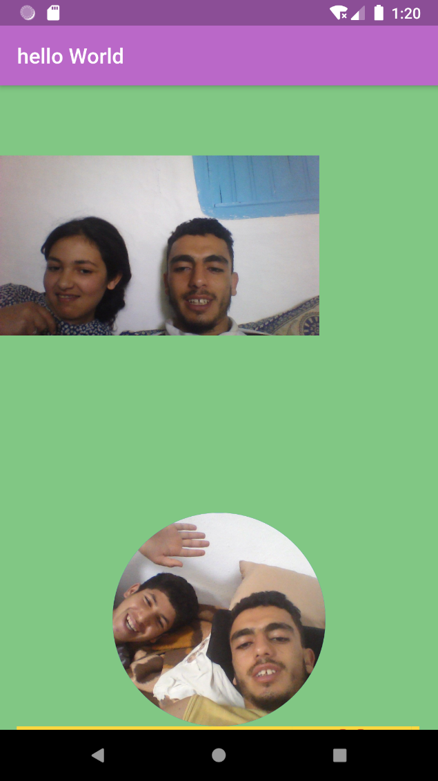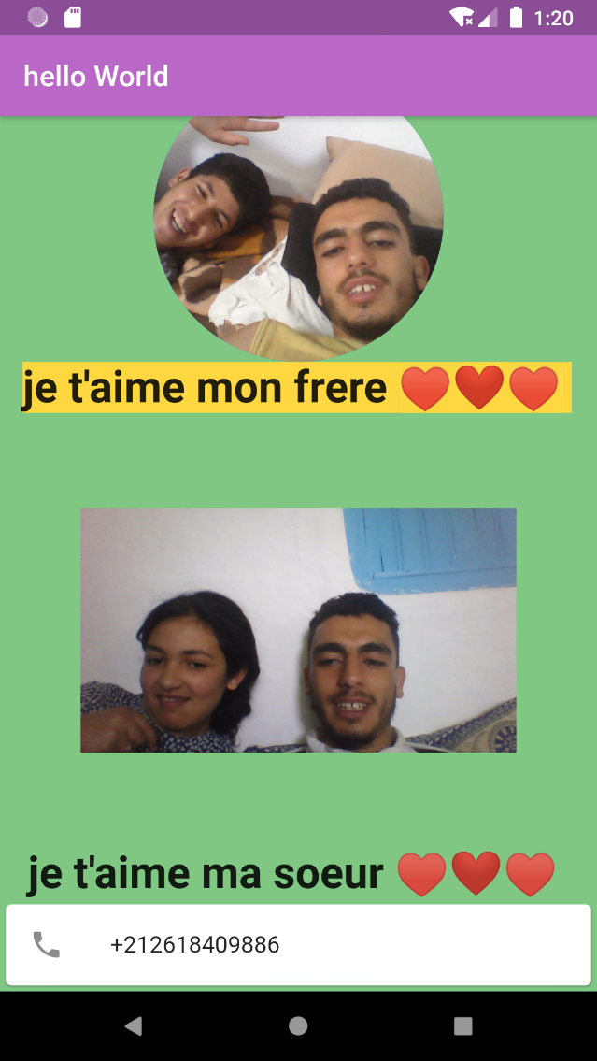

**Dicee**

import 'dart:math';  
import 'package:flutter/material.dart';  
  
void main() {  
 return runApp(  
 MaterialApp(  
 home: Scaffold(  
 backgroundColor: Colors.red,  
 //cette ligne est ecrase par la classe DicePage  
 appBar: AppBar(  
 title: Text('Dicee [RedaApp]'),  
 backgroundColor: Colors.red.shade900,  
 ),  
 body: DicePage(),  
 ),  
 ),  
 );  
}  
class DicePage extends StatefulWidget {  
 @override  
 _DicePageState createState() => _DicePageState();  
}  
  
class _DicePageState extends State<DicePage> {  
 int rand1=5;  
 int rand2=6;  
  
 void fct(){  
  
 setState(() {  
 rand1=Random().nextInt(6)+1;  
 rand2=Random().nextInt(6)+1;  
  
 // print('Second one is clicked !$a et $b');  
 });  
 }  
  
 @override  
  
 Widget build(BuildContext context) {  
  
 return Container(  
  
 color: Colors.teal.shade500,  
 child: Center(  
 child: Row(  
 crossAxisAlignment: CrossAxisAlignment.stretch,  
 mainAxisAlignment: MainAxisAlignment.center,  
 children: <Widget>[  
  
 Expanded(  
 child: FlatButton(  
 onPressed: (){  
 fct();  
 },  
 child: Image.asset('images/dice$rand1.png'),  
 //this flat button come automaticly by 16 of padding , so you don't need to add more paddnig by padding widget child: Image(  
 ),  
 flex: rand1,  
 ),  
  
 //by default the flex is one  
 //this ppte for says that this expanded is bigger twice than the first expanded  
  
 //SizedBox(width: 10,),  
 Expanded(  
 child: FlatButton(  
 onPressed: (){  
 setState(() {  
 fct();  
 // print('Second one is clicked !$a et $b');  
 });  
 },  
 child: Image.asset(  
 'images/dice$rand2.png',  
 color: Colors.yellow[200],  
 ),  
 ),  
 //a shorter way to construct an image asset  
 flex: rand2,  
 ),  
 ],  
 ),  
 ),  
  
 );  
 }  
  
}

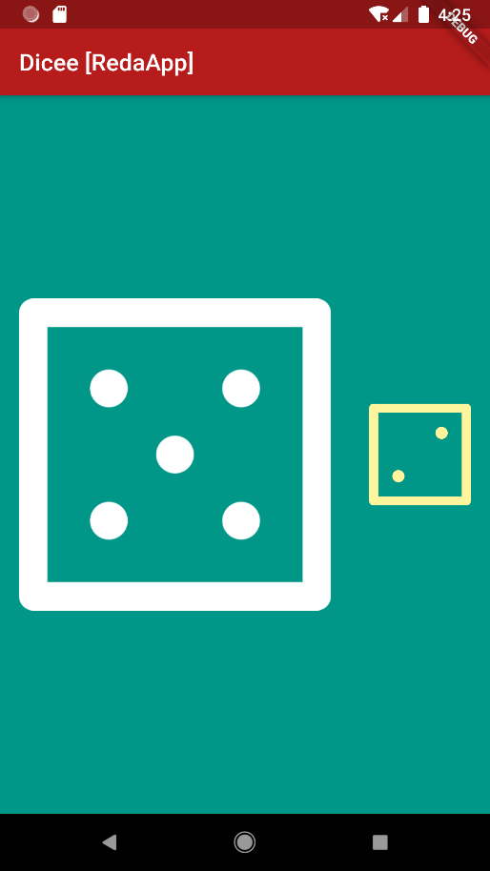

**8 Ball**

import 'package:flutter/material.dart';  
import 'dart:math';  
void main() => runApp(MaterialApp(  
 home: Scaffold(  
 backgroundColor: Colors.*amber*.shade300,  
 appBar: AppBar(  
 backgroundColor: Colors.*teal*.shade300,  
 title: Text('Ask me Anything'),  
 ),  
 body: MyApp(),  
 ),  
 debugShowCheckedModeBanner: false,  
 ));  
  
class MyApp extends StatefulWidget {  
 @override  
 _MyAppState createState() => _MyAppState();  
}  
  
class _MyAppState extends State<MyApp> {  
 @override  
 int i=1;  
 void fct(){  
  
 setState(() {  
 i=Random().nextInt(4)+1;  
  
 // print('Second one is clicked !$a et $b');  
 });  
 }  
  
  
 Widget build(BuildContext context) {  
  
 return Container(  
 //ces propriete de container permettre de realiser une background en gradient de couleurs   
 decoration: new BoxDecoration(  
 gradient: LinearGradient(  
 colors:[ Colors.*indigoAccent*,  
 Colors.*blue*[900],  
 Colors.*white70*,  
 ],  
 stops:[  
 0.1,  
 0.3,  
 0.5,]  
 ,  
 begin: FractionalOffset.*topCenter*,  
 end: FractionalOffset.*bottomCenter*,  
 ),  
 ),  
 child:  
 Center(  
 child: FlatButton(  
 onPressed: () {  
 setState(() {  
 fct();  
 print('aa');  
 });  
 },  
 child: Image.asset(  
 'images/ball$i.png',  
 ),  
 ),  
 ),  
 );  
 }  
}

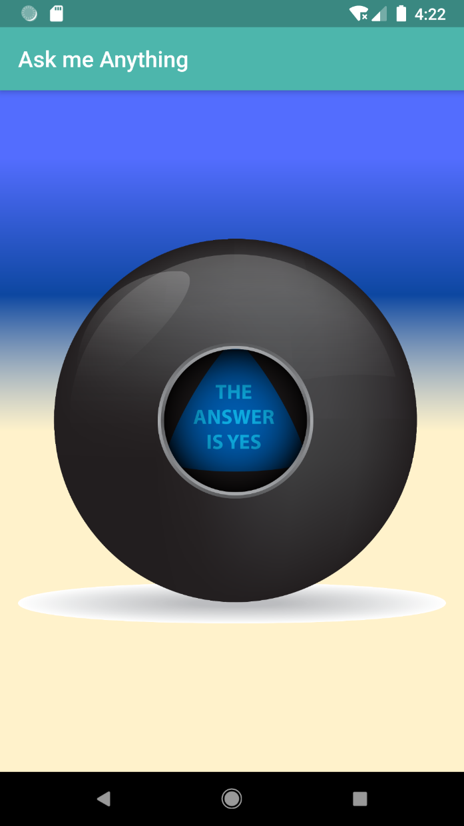

**________**

**Piano [flutter packages .. so useful]**

**_____________**

import 'package:flutter/material.dart';  
import 'package:audioplayers/audio_cache.dart';  
  
void main() => runApp(  
 MyApp(),  
 );  
  
class MyApp extends StatefulWidget {  
 @override  
 _MyAppState createState() => _MyAppState();  
}  
  
class _MyAppState extends State<MyApp> {  
 @override  
 //static AudioCache p=new AudioCache();  
 // //the twoo constructors are right  
  
 void Playit(int a) {  
 final p = AudioCache();  
 p.play('note$a.wav');  
 }  
  
 Container myWidget(int b, Color x) {  
 return Container(  
 color: x,  
 height: 86,  
 child: FlatButton(  
 onPressed: () {  
 setState(() {  
 Playit(b);  
 // print('Second one is clicked !$a et $b');  
 });  
 },  
 ),  
 );  
 }  
  
 Widget build(BuildContext context) {  
 return MaterialApp(  
 home: Scaffold(  
 backgroundColor: Colors.*black*,  
 appBar: AppBar(  
 backgroundColor: Colors.*indigoAccent*.shade100,  
 title: Text('composer Votre Musique 🎼🎶🎵🎹'),  
 ),  
 body: SafeArea(  
 child: Column(  
 //mainAxisAlignment: MainAxisAlignment.center,  
 crossAxisAlignment: CrossAxisAlignment.stretch,  
 children: <Widget>[  
 myWidget(1, Colors.*orange*),  
 myWidget(2, Colors.*blueAccent*),  
 myWidget(3, Colors.*green*),  
 myWidget(4, Colors.*orangeAccent*[100]),  
 myWidget(5, Colors.*purple*),  
 myWidget(6, Colors.*purple*.shade400),  
 myWidget(7, Colors.*purple*.shade100),  
 ],  
 ),  
 ),  
 ),  
 debugShowCheckedModeBanner: false,  
 );  
 }  
}

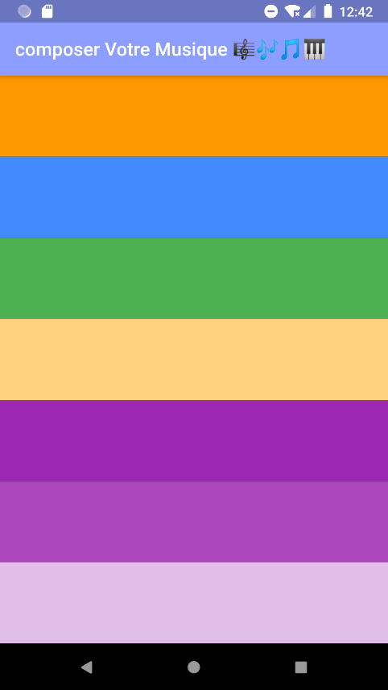

**________**

**Quiz**

**____________**

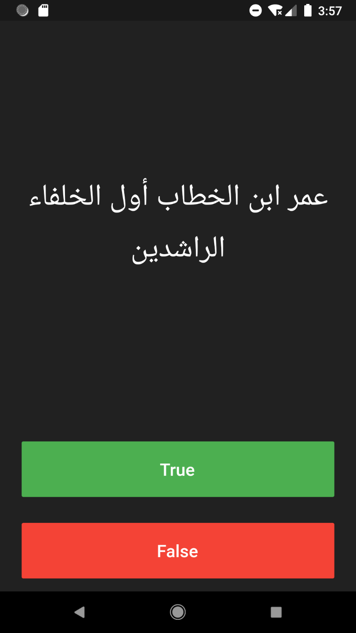

**________**

**Destini+Gradle example**

**At android/app/build.gardle**

**gardle:**

def localProperties = new Properties()  
def localPropertiesFile = rootProject.file('local.properties')  
if (localPropertiesFile.exists()) {  
 localPropertiesFile.withReader('UTF-8') { reader ->  
 localProperties.load(reader)  
 }  
}  
  
def flutterRoot = localProperties.getProperty('flutter.sdk')  
if (flutterRoot == null) {  
 throw new GradleException("Flutter SDK not found. Define location with flutter.sdk in the local.properties file.")  
}  
  
def flutterVersionCode = localProperties.getProperty('flutter.versionCode')  
if (flutterVersionCode == null) {  
 flutterVersionCode = '1'  
}  
  
def flutterVersionName = localProperties.getProperty('flutter.versionName')  
if (flutterVersionName == null) {  
 flutterVersionName = '1.0'  
}  
  
apply plugin: 'com.android.application'  
apply from: "$flutterRoot/packages/flutter_tools/gradle/flutter.gradle"  
  
android {  
 compileSdkVersion 28  
  
 lintOptions {  
 disable 'InvalidPackage'  
 }  
  
 defaultConfig {  
 // *TODO: Specify your own unique Application ID (https://developer.android.com/studio/build/application-id.html).* applicationId "redaelouahabi.destini"  
 minSdkVersion 16  
 targetSdkVersion 28  
 versionCode flutterVersionCode.toInteger()  
 versionName flutterVersionName  
 testInstrumentationRunner "android.support.test.runner.AndroidJUnitRunner"  
 }  
  
 buildTypes {  
 release {  
 // *TODO: Add your own signing config for the release build.* // Signing with the debug keys for now, so `flutter run --release` works.  
 signingConfig signingConfigs.debug  
 }  
 }  
}  
  
flutter {  
 source '../..'  
}  
  
dependencies {  
 testImplementation 'junit:junit:4.12'  
 androidTestImplementation 'com.android.support.test:runner:1.0.2'  
 androidTestImplementation 'com.android.support.test.espresso:espresso-core:3.0.2'  
}

**++++++++++++++++++**

**For the code : see the folder af projects ,,**

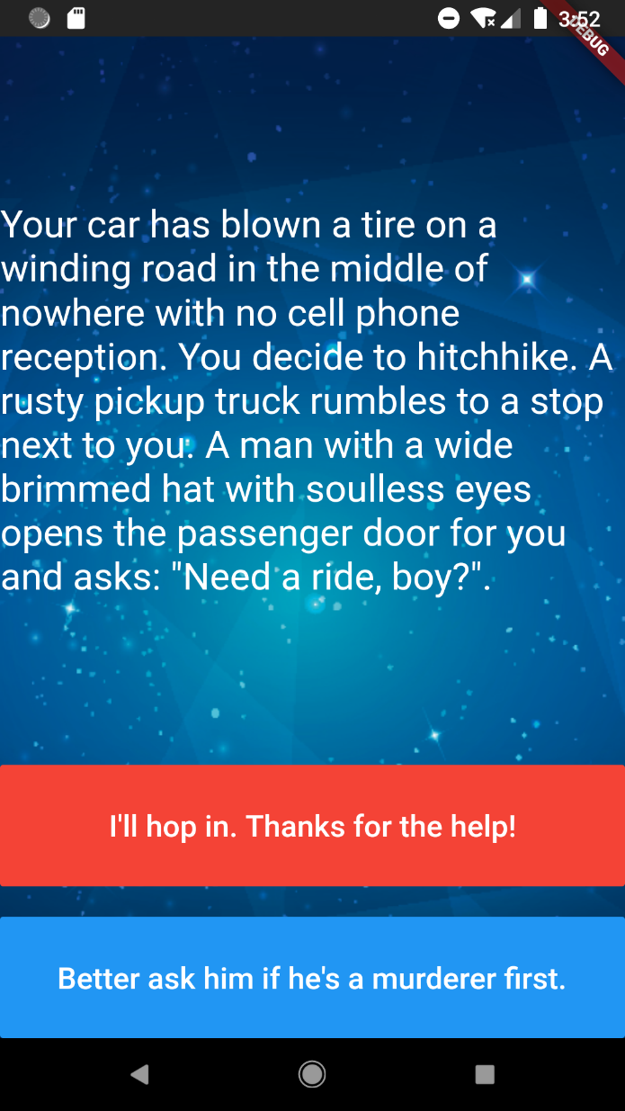

One of the best tuto of Angela : BMI calculator :

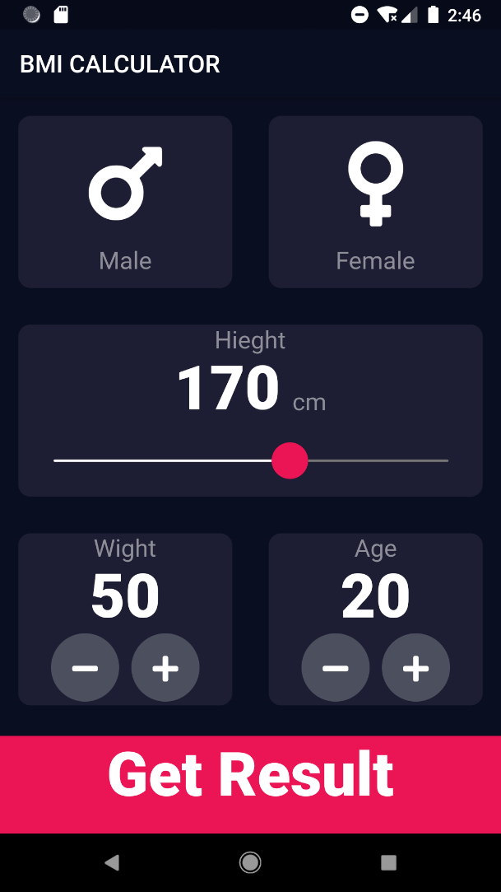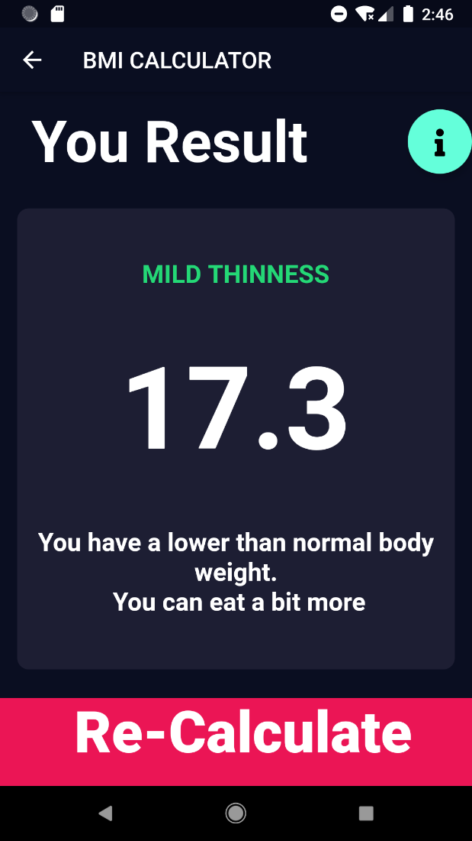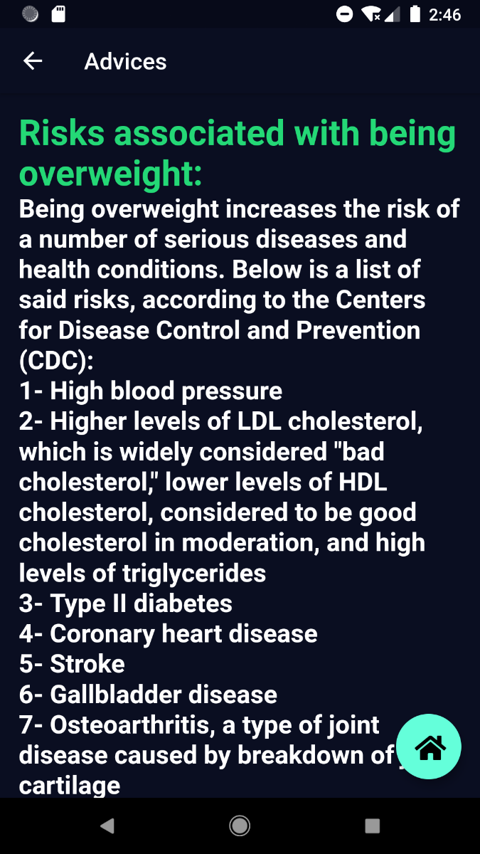

ALL MY NOTES:

***Flutter Trics :***

--comment/Uncomment all : clt+/

--hot reload from statless or statfull [dynamique] , you just need to type stless+enter

--**//TODO** : YOU WILL find it at todo/project/main => a list of to do [for managing the project ]

--if you want to write an **apostrophe** ' into a String , you may write 'aaa\'bbb' [we add a back slash]

--**shortcuts comments**: clt+maj+/ give /* */

clt+/ give //

--once you open the gardle at android/app , you have an error , but it doesn;t affect the exceution

***Project Trics :***

**--Change Icons** :

1. setting the icone without the website freely ! : src/main/res[le fichier des icones ] => new > image assets => choose your toof > set it looking > ✅✅
2. --Icone generators :https://appicon.co

**--for adding Fonts**:

as I saw it in Mi_Card => we add the fonts prom google fonts[install it , it will be a ziped file + extract the .ttf file => and add its to a folder named 'fonts' and after go to pubspec.yaml and add the folder ] as exactly we do for images :

flutter:

uses-material-design: true

assets:

- images/

fonts:

- family: Pacifico

fonts:

- asset: fonts/Pacifico-Regular.ttf

- family: Modak

fonts:

- asset: fonts/Modak-Regular.ttf

and for use in the Textstyle widget : fontFamily: 'Pacifico',

**--to change the name of the application :**

go to androidManifest.xml at app/src/main ,and after that change the label : android:label="ball projectt"

--**title propertie of Materialapp widget** : //APi,flutter : one line description used by the device to identify the app for user [which is the title may katekliki 3la lbt li kaye3tik tt les app ouvertes .. ](IMpoortant !)

--❓ what apk should i use : release ..

***Icons colors & != Links :***

--Icons class is more flexible from Images , because it is pixilated , and we can choose the color icon ,,

--colors.blue[900] is the same as colors.blue.shade900

free websites :

icons8[free icones/images]

vecteezy[free icones/images]

canva.com[design your own !!!]

--nice website for all **colors**[although a new arrangements ..] and also Icons liste : materialpalette.com

--freesound => freesound.org

--dribbble.com site of design[Idea_inspiration] of UI + <https://www.behance.net/> + <https://undraw.co/illustrations>

-- colorZilla : extention pipete [PS6] for firefox and chrome .[extarcting color's code]

***Widgets & properties:***

--**container** with no children try to be as big as possible .

--**container** with children size thier size to thier child size .[can have only 1 child]

--**SafeArea** => garanti the visibility to user , has one child .

--**margin** is for the outside of the container , and **padding** is for the inside of the container

-- **SizedBox** => for space

--**Expanded** widget is created for centering for by a horizontal line [ for Row] and a vertical line [ for a Column] , and it takes only one child [Expanded=Center/line+safeArea]

--**Expanded** widget must be placed inside a parent Widget [Colom /Row/Flex]

--for the visibility of any widget , we use **Visibility**(

visible: sb.buttonShouldBeVisible(),

child:...),

--for the **background Image | color** :

in a container , we use the proprieties :

decoration: BoxDecoration(

image: const DecorationImage(

image: AssetImage('images/background.png'),

fit: BoxFit.cover,

),

//border: Border.all(color: Colors.white , width: 8),

),

--**theme**:**themeData**(), widget in material app for theme => read the manuel API [ppte ..]

--we can also use a specefic flutter theme and add copywith (to change some ppte that we use in the themeData) [this is in the theme ppte in materialApp]

--for a particular widget theme , we can embaded the widget in a **Theme()** widget and add as an ppte data : ThemeData().. As I saw in BMI calculator

--**Slider() Widget** [you can choose the value Graphicly [BMI ]]

--to change the details of the **slider** [thumbcolors/shape(//size) ..] , we need to embed the slider widget by **SliderTheme** and in his ppte data , while the **SliderThemeData** need all his component/ppte[like an java Interface ] ,

we just use **SliderTheme.of(context).copyWith(ppte the we want change )**==> for the .**of(context)** it means that it extends just all ppte from the latest **buildContext** wich is in the widget build that return your current UI .

--**themedata** is soo rich in custumising our App, you can make your own ppte theme easly

--if you use one **materialApp** widget at only the **main** , and other pages are **only scaffold** => the *theme applicated is one in the materialaApp*

-**Debug:** one of useful property/args of scaffold : debugShowCheckedModeBanner: false,

instead of flutter inspector>more options>hide debug mode banner

-- **Color** for finding a color with a hexadecimal code #6x , we put instead of Colors.X : Color(0xff1b23c8), and the last 6x are the code of the color.

--I need to read more about scaffold and material app widgets ..

Styling properties :

-- what works for collumns , also aplly to rows !

--always think about play with **containers** [arranged in rows and columns]+ padding & margin Propreity [with their widget EdgeInsets.symetric or .all .. for the horizantal/vertical dimension ]

--there is **padding** widgets just for padding ppte and it has only one child!

--don’t forget **cross and axis and main lign alignement** !

--don't forget that **expanded** widget helps a lot at managing the size/taille of yours containers/widgets, it ditribute all the valable spaces between the widgets . we use expaded for each single container ./we can **crossaxisalignement** by streach

***Divers:***

--String interpolation: the ability to add a name of variable with a string [image$i []dart and i==1 [i love it with python and i did'nt find it in java ]]

--Comments are usefeul to show your logique in programming , like I initialise this var to 0 .. but not to say to someone , this line ,means that if this var==1 then its is a female gender {conventions ,,} , it's better to use enums; EXAMPLE:

*\* enum CarType{*

*Kar,*

*Lagrima,*

*Taxi,}*

*\* class Car{*

*CarType x;*

*//Constructor*

*Car({this.carstyle})*

*}*

*\* void main(){*

*//access to the element*

*Car y=Car(x: CarType.Lagrime);*

*}*

--instance variable=Field=property

--immutabe=unchangebale[like statlesswidget]

--you can do some online test with dart language on dratpad

--Advice angela yu : bilding a habit based on another habit !

***Packages :***

**--to install a flutter package:**

first serch the one who has more points, see the discription .. and after copy the name and add it in the yaml / :

dependencies:

flutter:

sdk: flutter

# The following adds the **Cupertino Icons** font to your application.

# Use with the CupertinoIcons class for iOS style icons.

cupertino_icons: ^0.1.2

audioplayers: ^0.10.0

**audioplayers** is the one here , the cupertino_icons is by default the package of icons ,,

so after this just click get package[android stdio go to site package to import it ,,]

and after that you just need to impor it ;

--for the music folder , we add it to section assets as the images exactly

--les **Alertes** !![yes/no – dialog_Alert ] <https://pub.dev/packages/rflutter_alert> et il sont apparu dans l'ecran par un structure pile : LIFO

--**font_awsome_Flutter** package : des Symboles speciales exple: [mars/venus] for BMI calculator

--**Geolocation** :

**geolocator: ^3.0.1 in dependencies

**import 'package:geolocator/geolocator.dart';

**call a fct that will assign to a string your coords

--**Functions /Variables dart** :

* don't forget your type of return+the return of the type

*new for me ** we can also declare a **fonction off 2 args** : type fct({Type1 p1, ..}) and for the call => fct(p1: v1 , ..)

but I advise you to choose this type because for example for the constructor , if you choose the other one with only() , you can't just use the default constructor .

--void main() => runApp( MyApp(), );

this is an arrow fct , that's mean that it's composed by a single line of code , and we can just use an arrow '=>'

[**fat arrow** Vs **slim arrow**(->) ] anstead of {}

--const are defined at the compile time; while the final can be assigned after this time ; like extractine the current time ,,

--**setState((){});** must be in his class

-- **Listeners**: **GestureDetecto**r(), for dettecting onTab() longPress() ..

--**Enums** : enum EnumName{typeA,typeB,typeC} => call : EnumName.typeA

-- **Casting**

int=> double :: toDouble(),

--double.round():: round to an integer

--double.parse(String);

-- checking if a parameter p set on null => if it is not null use it ; else use a default value d ::

**p ?? d** //on one line of code by the null aware operator: '??' [like optional java]

--Dart**Ternary Operator** : we use

*condition ? DoThisIfTrue : DoThisIfFalse ;*

//instead of if(condition) DoThisIfTrue ; else DoThisIfFalse ; we can assign a return value of an Ternary condition in a Variable !! because it's one line code

--we can set a **fonction as argument of othe Fct** in flutter[Or also constructor] ! for preserving repititions ..

for example

*Calculation(n1,n2,add/multiply ,,){return x or doesn't return anything ,,}*

Or by creating a variable

*Function f=(n1,n2,add/multiply ,,){return x or doesn't return anything ,,}*

**for the call in an arguemt with class constructor: we shlouldn't add the parenthesis with the function, and for the manilulation :

***className.FunctionName=> Fction name***

***className.FunctionName()=> Fction behavior***

***Navigation / routes - datatype:***

--if you want just to use a **Stack** data structure for the Navigation between routes [cad pages] , you should use the two actions [usely in a Button] : *\*Navigator.push(context,MaterialPageRoute(builder: (context){*

*return DicePageState();*

*}));*

*\* Navigator.pop(context);//for Poping*

--for more precision : =>*; egale a {return*;}

--& **if its a complexe routes** =>

we use **map datastucture** in a ***routes*** ppte in **materialApp** Exple :

routes: {

'Our':(context)=>InputPage(),

'/': (context)=> TestResult(),

},

and we should have in Place Of **home** ptte => **initialRoute: 'Our'**,//the key Of the Page

=> and for calling the others Pages **=> Navigator.pushNamed(context, 'Our');**

***Map Structure :***

--declaring a map :

*Map<keyType,ValueType/*if you want to specify*/> mapName {*

*Key:Value , **}*

--calling it: *mapName[Key]*

--if we try to acced to an value by a key that doesn't exist > we will find null , so we can anytime chek the existance of any Value

--add another element :

*mapName[newKey]=newValue*

--map unordered dataType, we have some methodes like: *.length , .keys ,.values ,*

--dart gives us the possibility to declar an dataType outside any class

--for **passing data over Pages/Routes** , we sould passing it by the constructor of pages/classes at the level of the Navigator,

--BMI was soo helpful for me , I learned a lot of things[theme costumizing/pass fct overs argumets ..]

--**asynchronous Programming** [doing thing while others thing is also in execution] Vs Synchronous [one task has his own time /sequencial Programming]

--Futures in dart is the same as **promises** in JS

--**dart Futures: *Async & await*** are so important in terms of reloading data manipulation:

--Future is like a recite of : you will have this data once it's ready for you

--we could specify the **data Type of a Future** by: *Future<String>*

--**Widget Life cycle** on stateful widgets:

***\*\*initState()*** //caled once when the widget was born ;

***\*\*build :*** called anytime the build core is changed !

***\*\*deactivate()*** : at the end of widget's life

--**handling exceptions** by ***try{} catch(e){}***

--I'm so surprised that we can do in a **build method inside of try/catch**:

try{

return scaffold(**)

}

catch(e){

return scaffold(***)

}

--**throw Exception**[predefinie] or throw String => is a way to throw an exception in certain personnalised conditions

******PS*******

--canva => tempelate

--couleur harmoniques

--in design => li kaykhedmou fih les journaux [aussi pour latex]...

**Articles :**

<https://medium.com/flutter-community/flutter-visual-studio-code-shortcuts-for-fast-and-efficient-development-7235bc6c3b7d>

<https://stackoverflow.com/questions/47006906/developing-for-ios-device-in-windows-environment-with-flutter>

**commands:**

**Flutter create aaaa_aaa //create app**

**flutter pub get //update pckges**

**–help //add it to any commands to learn more**

**flutter create . //create web version**

**flutter run //run app**

**flutter build [ios ..]**

**flutter run -d chrome //run on chrome**

**flutter create . // create a web version 4 existing app**

**flutter clean //clean project**

**flutter build apk --release == flutter --no-color build apk //build apk**

**flutter build web --release //build web version**

**flutter install //install packages**

**flutter run –verbose //more details what went wrong.**

**flutter doctor --android-licenses //accept flutter licenses**

**flutter devices // list devices**

**flutter doctor // doctoring flutter packages**

**flutter doctor --verbose == flutter doctor -v**

**Add Web Version v1 [qdima]:**

You can add the app to the existing flutter project as well. Here are some steps that I followed

1: Create a new branch to not mess things up in existing branch if you are starting with flutter web for the first time.

2: flutter channel master

3: flutter config –enable-web: Now you may or may not see the new Dart SDK being downloaded.

4: flutter create –org package_name .: This will add the web files in your project.

5: flutter devices: You must see chrome listed now.

6: flutter run -d chrome: If you see something like project not configured for the web then try step 3 again and reopen your editor.

**Generate APK + IPA for android / iOS :**

<https://codemagic.io/app/60d85b6917ecbd2eb8a36b2a/build/60d85baf19e6aafa72e10d4d>

You could do that with a Mac (or Hackintosh, or VM), but since we don’t have access to a macOS machine we can use one remotely via **Codemagic** or **Travis CI** — completely **free**! (as long as your project is on a GitHub, Bitbucket or GitLab repository).

First, create an account or sign in to [codemagic.io](http://codemagic.io/).

Then, click the settings (gear) icon next to your app. Scroll down and click on “Build”. Make sure Mode is set to Debug, and select iOS under Build for platforms.

After that, build the app (**Start your first build**).

Codemagic will send you an **.app** file via email. Rename it so that it ends with .zip. Extract it, and you’ll get a folder called Runner.app. Create a folder called Payload and place Runner.app there. Finally , compress the folder called Payload — this will be your IPA file (you may rename it to **.ipa**).

<https://stackoverflow.com/questions/61732409/plugin-project-firebase-core-web-not-found>

Random Color :

color: Color((math.Random().nextDouble() * 0xFFFFFF).toInt())  
 .withOpacity(1.0),